Experiment No.: 8
1.Title: Access and Validate form fields using events; design a gym admission form with live input using html,css,js.
2. Software/Tools Required: VSC,HTML,CSS
3. Theory: This experiment demonstrates form field validation using JavaScript events.
Different events like input, change, and submit are used to check user-entered data.
If the input is invalid, an error message is displayed, while valid input is accepted.
4.Codes:
index.html:
<!DOCTYPE html>
<html>
<head>
<title>Gym Admission Form</title>
<link rel="stylesheet" href="style.css">
</head>

<body>

<div class="container">

<h1>Gym Admission Form</h1>

<form id="gymForm">

<!-- Full Name -->
<label>Full Name:</label>
<input type="text" id="name" placeholder="Enter your full name">
<span id="nameError" class="error"></span>

<!-- Email -->
<label>Email:</label>
<input type="text" id="email" placeholder="Enter your email">
<span id="emailError" class="error"></span>

<!-- Mobile -->
<label>Mobile Number:</label>
<input type="text" id="mobile" placeholder="Enter 10 digit mobile number">
<span id="mobileError" class="error"></span>

<!-- Age -->
<label>Age:</label>
<input type="number" id="age" placeholder="Enter your age">
<span id="ageError" class="error"></span>

<!-- Membership -->
<label>Membership Plan:</label>
<select id="membership">
<option value="">-- Select Plan --</option>
<option value="monthly">Monthly</option>
<option value="quarterly">Quarterly</option>
<option value="yearly">Yearly</option>
</select>
<span id="membershipError" class="error"></span>

<button type="submit">Submit Application</button>

<p id="successMessage"></p>

</form>

</div>

<script src="script.js"></script>

</body>
</html>

Style.css:
body {
font-family: Arial, sans-serif;
background-color: #f2f2f2;
}

.container {
width: 400px;
margin: 50px auto;
padding: 25px;
background-color: white;
border-radius: 10px;
box-shadow: 0 0 10px gray;
}

h1 {
text-align: center;
margin-bottom: 25px;
}

label {
display: block;
margin-top: 15px;
font-weight: bold;
}

input,
select {
width: 100%;
padding: 10px;
margin-top: 5px;
box-sizing: border-box;
border: 1px solid #aaa;
border-radius: 5px;
}

input:focus,
select:focus {
outline: none;
border: 2px solid blue;
}

.error {
display: block;
color: red;
font-size: 13px;
margin-top: 4px;
}

button {
width: 100%;
margin-top: 25px;
padding: 12px;
background-color: black;
color: white;
border: none;
border-radius: 5px;
cursor: pointer;
}

button:hover {
background-color: #333;
}

#successMessage {
color: green;
text-align: center;
font-weight: bold;
}
Script.js:
// Accessing form fields
let nameField = document.getElementById("name");
let emailField = document.getElementById("email");
let mobileField = document.getElementById("mobile");
let ageField = document.getElementById("age");
let membershipField = document.getElementById("membership");

let form = document.getElementById("gymForm");

// Name validation
nameField.addEventListener("input", function () {

let name = nameField.value.trim();

if (name === "") {
document.getElementById("nameError").textContent =
"Name is required.";
}
else if (!/^[A-Za-z ]+$/.test(name)) {
document.getElementById("nameError").textContent =
"Name should contain only alphabets.";
}
else if (name.length < 3) {
document.getElementById("nameError").textContent =
"Name must contain at least 3 characters.";
}
else {
document.getElementById("nameError").textContent = "";
}
});

// Email validation
emailField.addEventListener("input", function () {

let email = emailField.value.trim();

let emailPattern = /^[^\s@]+@[^\s@]+\.[^\s@]+$/;

if (email === "") {
document.getElementById("emailError").textContent =
"Email is required.";
}
else if (!emailPattern.test(email)) {
document.getElementById("emailError").textContent =
"Enter a valid email address.";
}
else {
document.getElementById("emailError").textContent = "";
}
});

// Mobile validation
mobileField.addEventListener("input", function () {

let mobile = mobileField.value;

if (mobile === "") {
document.getElementById("mobileError").textContent =
"Mobile number is required.";
}
else if (!/^[6-9][0-9]{9}$/.test(mobile)) {
document.getElementById("mobileError").textContent =
"Enter a valid 10 digit mobile number.";
}
else {
document.getElementById("mobileError").textContent = "";
}
});

// Age validation
ageField.addEventListener("input", function () {

let age = Number(ageField.value);

if (ageField.value === "") {
document.getElementById("ageError").textContent =
"Age is required.";
}
else if (age < 16 || age > 60) {
document.getElementById("ageError").textContent =
"Age must be between 16 and 60.";
}
else {
document.getElementById("ageError").textContent = "";
}
});

// Membership validation using change event
membershipField.addEventListener("change", function () {

if (membershipField.value === "") {
document.getElementById("membershipError").textContent =
"Please select a membership plan.";
}
else {
document.getElementById("membershipError").textContent = "";
}
});

// Submit event
form.addEventListener("submit", function (event) {

event.preventDefault();

// Trigger validation
nameField.dispatchEvent(new Event("input"));
emailField.dispatchEvent(new Event("input"));
mobileField.dispatchEvent(new Event("input"));
ageField.dispatchEvent(new Event("input"));
membershipField.dispatchEvent(new Event("change"));

// Check if there are any errors
let errors = document.querySelectorAll(".error");

let hasError = false;

errors.forEach(function(error) {
if (error.textContent !== "") {
hasError = true;
}
});

if (!hasError) {
document.getElementById("successMessage").textContent =
"Gym admission form submitted successfully!";
}
else {
document.getElementById("successMessage").textContent = "";
}
});
5.Output: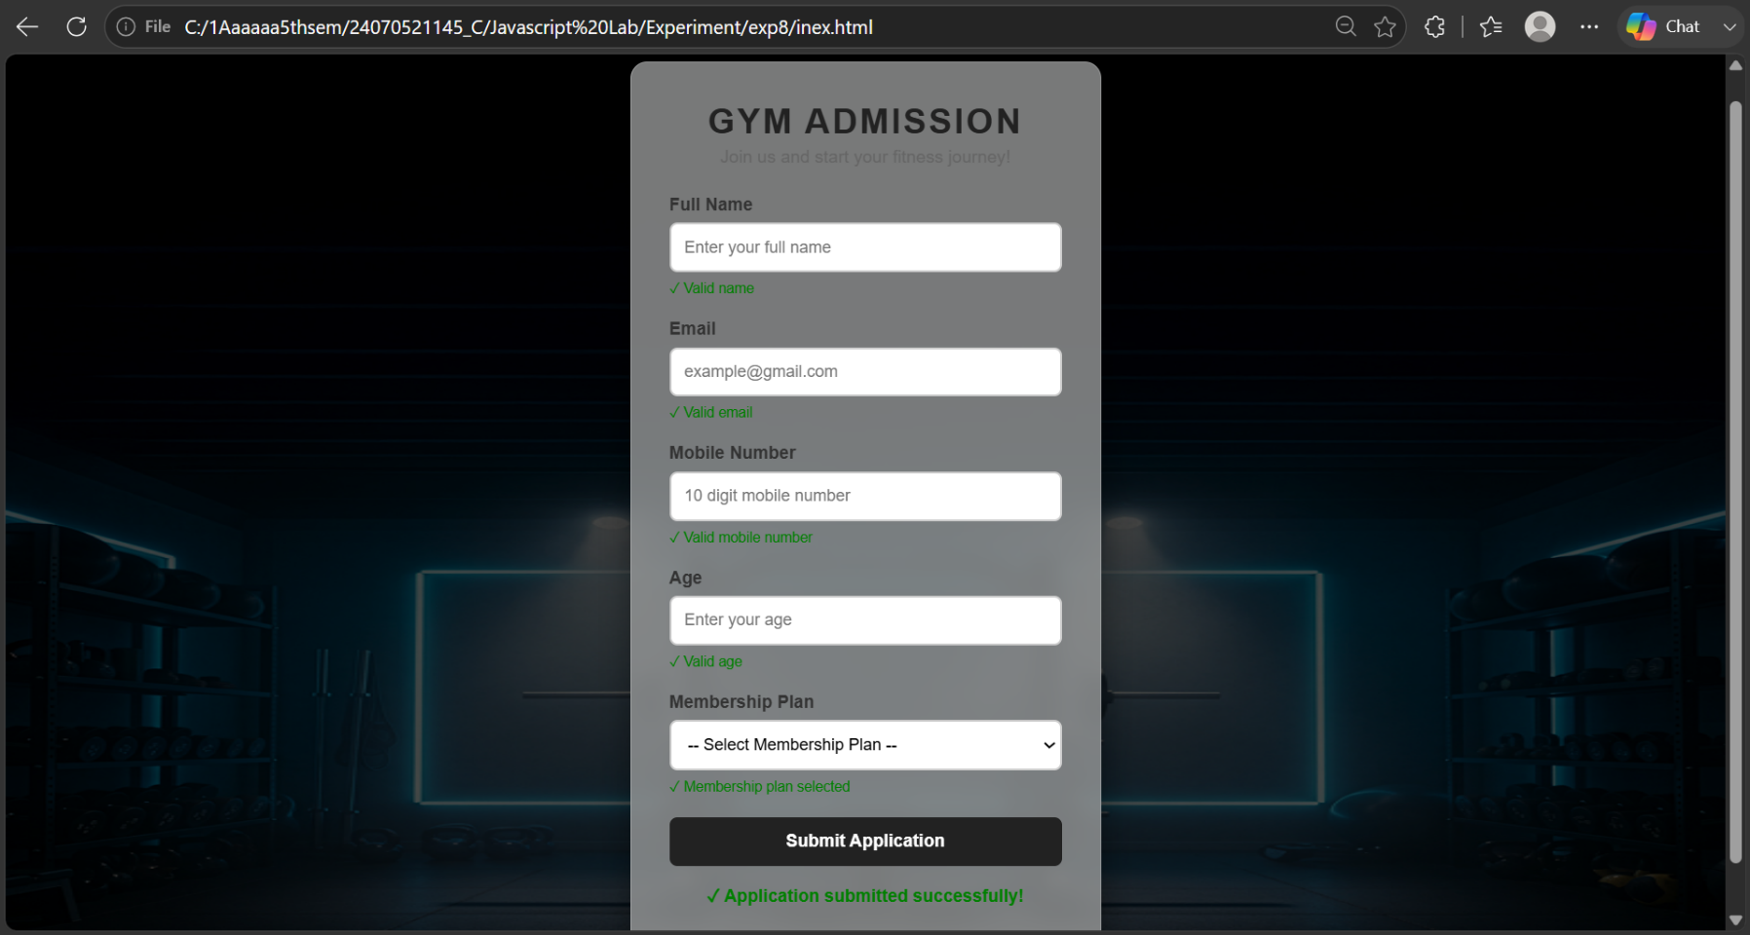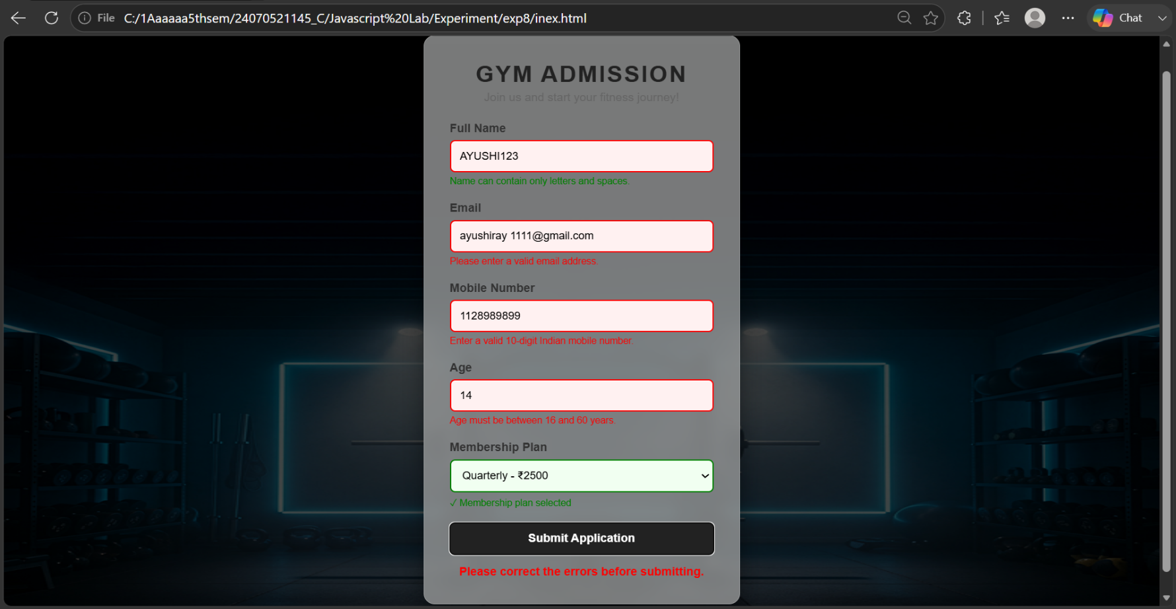
Result: The Gym Admission Form was successfully created using HTML, CSS, and JavaScript.
The form validates user inputs live and displays error messages for invalid entries.
Events such as input, change, and submit were successfully implemented.
Valid details are accepted, while incorrect details are rejected with suitable error messages.

